GAS LEAKING AND MONITORING SYSTEM

"It saves the industrialists a lot of money"

"It saves many careless mistakes"

"It can also prevent global warming"

"It is useful but with precautions"

"Proper testing should be done"

"It causes employment loss"

"It is a time efficient system"

faster response

Low maintenance cost

"What if It does not sense at all?"

"It can assure better safety"

"It saves industry and society"

Ensure safe environment

"It saves man power"

Saves business risk

"The quick alerts saves the life"

Cost efficient installation

Reliable in All Environmental Conditions

"Many industries can be benefited"

"Social vital sytem"

Precautions can be taken in advance

"Typically saves destruction"

"Certainly a must needed system"

Time efficient on detecting.

long life is expected

"Essentially a time saving system"

"Focuses on potential health care".

Easy to Use the system

Protection to nearby schools, hospitals etc,.

Sensors failure create false alarming

User friendly application

Gain insight and understanding on solving customer problems.

1

A collaborative and deeper insight of real time automated gas leaking and monitoring system for industries

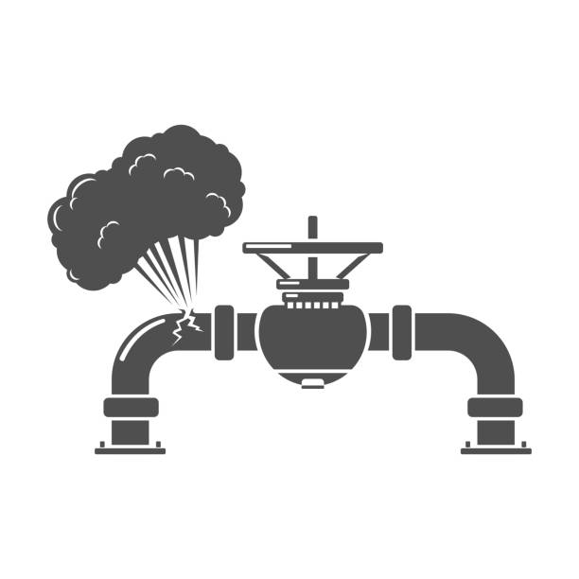

"Industrial loses can be avoided"

It will definitely save some lives

This system will prevent social damage

Industrial workers can be confident

The surrounding can be less toxic

Prevent of exposure to both human and animals

False sensing leads to sudden collapse

False detection cause false alerts

Delay in sending alerts

System will provide 24/7 monitoring

Various toxic gases detected

Advance alert system

Provides quick leak alerts

Need a prior precaution steps

Level of risk can be false sometimes

Detection in advance

Efficient risk management

Provides robust protection

Major accidents are prevented